RCA-EfficientNet: A Lightweight Residual Channel Attention-Based Model for Ball Bearing Fault Diagnosis
V. Vinay Shankar¹, G. Rithanya Grishma¹ and Sathya Narayana Sharma K¹*
Department of Mathematics, School of Advanced Sciences,
Vellore Institute of Technology, Vellore, Tamil Nadu, India.
*Corresponding author: Sathya Narayana Sharma K (sathyanarayana.k@vit.ac.in)

Abstract
Obtaining fault diagnosis of rolling element bearings is crucial for the reliability and safety of industrial machinery. In this study, we propose RCA-EfficientNet, a lightweight deep learning model combining EfficientNet-B0 and a residual channel attention technique to represent more features. This approach is not as laborious as conventional hybrid approaches and does not involve model construction but rather features refinement to further improve classification performance.
The residual channel attention module selectively emphasizes informative feature channels while maintaining their backbone representation, which allows for better detection of faults. The model is trained on an enhanced image-based dataset containing 25,567 samples and assessed using separate validation and test sets to verify the model's performance objectively.
RCA-EfficientNet has an accuracy of 97.86%, precision of 96.91%, recall of 98.95%, F1 score of 0.9792, and Cohen’s Kappa of 0.9572. The high recall indicates the model can be used to determine whether there are false positives in fault detection applications.
We show that the lightweight, with residual attention, models outperform the hybrid and transformer models in texture-driven industrial data sets. Our results show that the light weight models are a reliable and efficient alternative for real-world deployment.
Keywords: Bearing Fault Diagnosis, EfficientNet, Residual Channel Attention, Deep Learning, Rolling Bearings

Introduction

Rolling element bearings are important parts of industrial machinery; failure of these bearings could cause machine downtime and economic losses. Fault detection is important in maintaining system integrity and predictive maintenance. The increasing availability of visual data, such as image information, makes the use of image information in fault diagnosis an attractive option for automatic condition monitoring [1].
Deep learning, such as Convolutional Neural Networks (CNNs), has shown remarkable ability to learn discriminative features directly from the data [5, 6]. It is particularly effective at capturing texture pattern in local areas that are commonly seen on surfaces. In addition, models based on advanced architectures such as EfficientNet are capable of scaling models and running much faster.
For feature representation, hybrid algorithms that combine CNNs with transformer models have recently been proposed [2, [3,], [8]. Although these approaches are designed to capture local and global dependencies, they often add complexity and computational overhead. In many industrial domains where fault characteristics are primarily localized, such models are not optimized.
Attention mechanisms have been widely employed to learn more features by focusing on relevant information in the data [9], [10]. Channel attention enables selective focus on important feature maps, while residual connections keep crucial information intact during transformation. Such attention provides a straightforward way to improve discriminative abilities without adding additional complexity.
Even with all of these advances, we still need models that provide high accuracy while maintaining computational efficiency and simplicity. Many existing models rely on multi-branch models or transformers that may not be appropriate for fault diagnosis based on texture information.
As a result, we present RCA-EfficientNet, a lightweight approach that combines EfficientNet-B0 with a residual channel attention. It is a simplified representation of features rather than an overly complicated model. We have conducted many experiments and found that our model performs better than either the baseline model, transformer model, or hybrid model in terms of recall and overall robustness.

Methodology

I. Model Architecture
The proposed RCA-EfficientNet architecture is lightweight for image-based bearing fault diagnosis. The architecture includes feature extraction, feature refinement, and classification.
As the backbone network, we employ EfficientNet-B0. It has high computational efficiency and can easily learn features. For this purpose, images are resized to pixels and processed to extract high-level feature representations. We use global average pooling to produce a compact feature vector with minimal number of parameters while keeping spatial information.
II. Residual Channel Attention Mechanism
In order to perform discrimination in features more efficiently, we have integrated a channel attention module. Channel attention is a two-layer fully connected network activated by non-linearity. It is then followed by a sigmoid function to obtain channel weights.
We use a residual attention formulation to preserve the important feature information. Hence, we extract the feature vector and represent the weighted attention of each pair of eyes. The refined feature representation is defined as follows:
$$F^{'}= F+(F⋅A(F))$$
This approach preserves the original features while enhancing information channels for greater stability and classification performance.
III. Dataset Description and Preprocessing
The dataset used in this study is the Ball-Bearing Computer Vision Model from a publicly accessible Roboflow repository [12]. It includes labeled images representing defective (Bad) and non-defective (Good) bearing for fault diagnosis by image analysis.
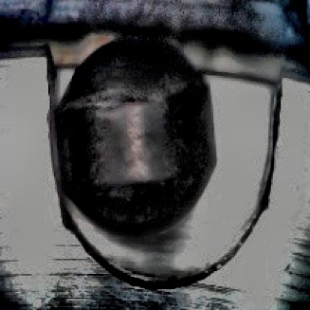
(a) Defective Bearing (b) Normal Bearing
Fig. 1. Sample images from the dataset showing (a) defective and (b) nondefective bearings.
To increase data diversity and generalize the model, we systematically augment the training set to attain a total of 25,567 images. The training set is made up of 25,000 images for training, 380 images for validation, and 187 images for testing. We only augment the training set to eliminate the risk of leakage and ensure an objective evaluation.
All images are resized to $224×224$pixels. The augmentation process involves geometric transformations, intensity changes, and noise injection to simulate variation in the appearance of bearings.
IV. Training Strategy
The model is trained with the AdamW optimizer at a learning rate of $1×{10}^{-4}$ and a weight decay of $1×{10}^{-4}$. A cosine annealing scheduler is employed to control the training rate. Cross-entropy loss with label smoothing is used as the objective function.
Training takes 10 epochs and a batch size of 16. Partial fine-tuning is performed by storing the first layer of the EfficientNet backbone and updating only the final blocks to keep costs low and performance high.
All of the experiments are performed on a GPU-enabled environment using PyTorch.

Results and Discussion
The performance of RCA-EfficientNet is assessed using standard classification metrics, such as accuracy, precision, recall, F1-score, and Cohen’s kappa. The performance is compared with the corresponding CNN baseline, EfficientNet-B0, ResNet50, transformer-based models, and hybrids in Table I.
RCA-EfficientNet is 97.86% accurate, recalls 98.95%, has a F1-score of 0.9792, and Cohen’s kappa of 0.9572, indicating excellent classification consistency and reliability. Table I lists the classification performance of all models.
Model | Accuracy | Precision | Recall | F1-score | Kappa
RCA_EfficientNet | 0.9786 | 0.9691 | 0.9895 | 0.9792 | 0.9572
CNN | 0.9733 | 0.9500 | 1.0000 | 0.9744 | 0.9465
EfficientNet + Attention Hybrid (V2) | 0.9733 | 0.9688 | 0.9789 | 0.9738 | 0.9465
EfficientNet-B0 | 0.9679 | 0.9588 | 0.9789 | 0.9688 | 0.9358
DeiT | 0.9679 | 0.9406 | 1.0000 | 0.9694 | 0.9357
EfficientNet + Transformer Hybrid | 0.9679 | 0.9588 | 0.9789 | 0.9688 | 0.9358
ResNet50 | 0.9626 | 0.9583 | 0.9684 | 0.9634 | 0.9251
EfficientNet + Attention Hybrid (V1) | 0.9626 | 0.9681 | 0.9579 | 0.9630 | 0.9251
CNN-Based Hybrid Model | 0.9465 | 0.9670 | 0.9263 | 0.9462 | 0.8931
Table I Performance comparison of different models for bearing fault diagnosis.
Receiver Operating Characteristic (ROC) curves provide additional insight into the discriminative ability of the models. In Fig. 2, our proposed RCA-EfficientNet performs well across different thresholds of classification, indicating that the classes of defective and non-defective data are easily separated.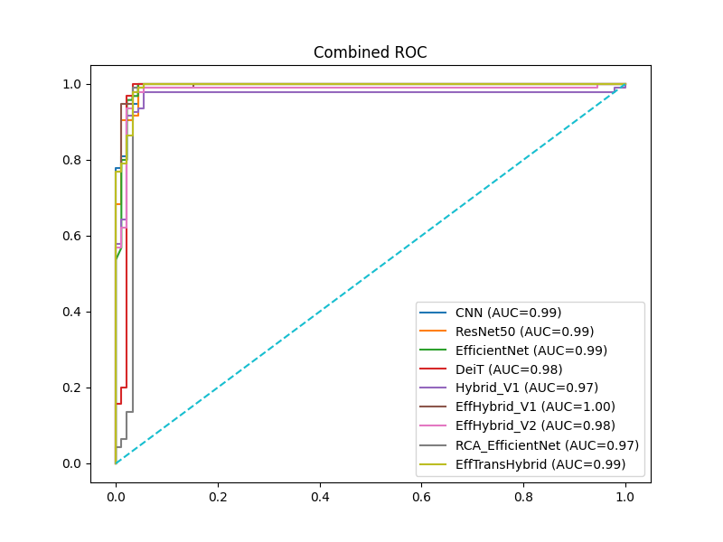
Fig 2. Receiver Operating Characteristic (ROC) curves comparing the performance of different models.
The classification performance is also illustrated in Fig. 3. The confusion matrix demonstrates that most samples are correctly classified with very few misclassifications between classes. The high recall indicates that the model can correctly identify defective bearings and to reduce false negatives as well.
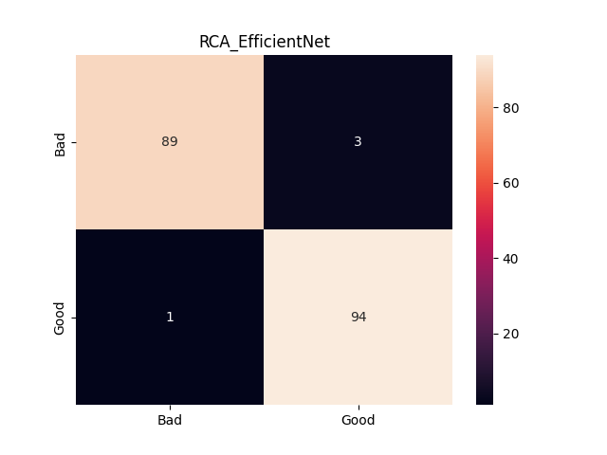
Fig. 3. Confusion matrix of the proposed RCA-EfficientNet model with classification performance.
The improvements in recall and Cohen’s kappa compared to base model and hybrid models are largely attributed to the residual channel attention mechanism, which increases feature representation while maintaining crucial information. These results suggest that refinement of feature representations is more effective than introducing more complexity in architecture.
Transformers and multi-branch hybrid models perform poorly in this task, most likely because the data set is structured so that faults have a local texture nature and are not dependent on each other over long periods of time. Lightweight CNN architectures with attention mechanisms are preferable.
Overall, the proposed RCA-EfficientNet balances accuracy, robustness, and computational efficiency to be employed for bearing fault detection in the real world.

Conclusion
This paper presents RCA-EfficientNet, a light deep learning model for ball bearing fault diagnosis that utilizes EfficientNet-B0 and a residual channel attention technique. We attempt to improve the representation of features by efficiently refining the architecture, rather than adding more complexity.
RCA-EfficientNet outperforms the baseline model, transformer model, and hybrid model in its accuracy (97.86%) and recall (98.95%). These results show the effectiveness of residual channel attention in learning discriminative features while maintaining important information.
The study also indicates that light CNN-based designs are better suited to texture-driven industrial datasets than more sophisticated hybrid or transformer-based designs. The model proposed here is computationally efficient and reliable for fault diagnosis.
Future research will explore multi-class fault classification and explainability techniques such as Grad-CAM that will help their understanding and use in industry.

References
- Chandrakala, C.B., Karumanchi, S.S., Raghudathesh, G.p. et al. Ball bearing fault detection using an acoustic based machine learning approach. Sci Rep 16, 3845 (2026). https://doi.org/10.1038/s41598-025-33978-5
- Xia, L., Wang, D., Chen, C., Xie, C., & Deng, J. (2026). Bearing fault diagnosis method based on IMSE-CNN-Transformer and immune genetic algorithm optimization. Applied Soft Computing, 194, 114918. https://doi.org/10.1016/j.asoc.2026.114918
- Wang, M., & Wang, Z. (2026). A novel CNN-transformer integrated with cross-attention mechanism for intelligent diagnosis of rolling bearing faults. Digital Signal Processing, 175, 105996. https://doi.org/10.1016/j.dsp.2026.105996
- Huang, M., Shen, C., Zhang, Y., Zhang, Z., Sun, L., & Liu, H. (2025). Self-powered wireless sensor node with hybrid energy harvesting and DL-enhanced vibration sensing for bearing fault diagnosis. Information Fusion, 129, 104055. https://doi.org/10.1016/j.inffus.2025.104055
- Chen, S., Zhang, B., He, X., Chang, X., Shao, Y., & Gao, Z. (2026). A lightweight CNN-ISO collaborative optimization framework addressing high-dimensional redundancy and class imbalance in rolling bearing fault diagnosis. Measurement, 271, 120912. https://doi.org/10.1016/j.measurement.2026.120912
- Mandal, S., Bhardwaj, P., Kumar, R., Mishra, C., & Hui, N. B. (2026). Rolling element bearing fault diagnosis: A comparative study of deep learning-based 1-D and 2-D CNN models. Proceedings of the Institution of Mechanical Engineers Part C Journal of Mechanical Engineering Science, 240(7), 2193–2206. https://doi.org/10.1177/09544062251407288
- Wang, X., Fang, L., Che, J., & Wang, Z. (2026). Few-Shot rotating machinery bearing fault diagnosis with denoising Diffusion-Based data augmentation. IEEE Sensors Journal, 26(6), 8520–8535. https://doi.org/10.1109/jsen.2026.3653364
- Wang, H., Ren, Z., & Qi, J. (2026). TFD-Trans: Time-frequency hierarchical decomposition transformer for mechanical fault diagnosis. Advanced Engineering Informatics, 71, 104303. https://doi.org/10.1016/j.aei.2025.104303
- Sharma, A. K., & Verma, N. K. (2025). A novel vision transformer with selective residual in multihead self-attention for pattern recognition. Pattern Recognition, 172, 112497. https://doi.org/10.1016/j.patcog.2025.112497
- Wang, H., Fang, G., Cui, X., & An, X. (2026). Parallel Axial Attention and ResNet-Based Bearing Fault Diagnosis Method. Electronics, 15(4), 899. https://doi.org/10.3390/electronics15040899
- Hu, B., Zhu, J., Liang, S., & Ting, L. (2026). Multi-Domain Representation Learning for Bearing Fault Diagnosis with Phase and Transient Preservation. Applied Sciences, 16(4), 1846. https://doi.org/10.3390/app16041846
- Roboflow, “Ball-Bearing Computer Vision Model Dataset,”Available: https://universe.roboflow.com/ballbearing-myp55/ball-bearing-o64ss, accessed Apr. 2026.

